AP Calc AB Name: _______________

______________ _____________

WS Assessment

Target 23:

Volume with cross sections

**I can:**

* Calculate the volumes of solids with known cross sections using the definite integral

Unit 8: Applications of Integration

HW Target 23 Unit 8 Progress Check FRQ

Warm Up: Find the area of the following figures:

1. A square with sides of length x

2. A square with diagonals of length x

3. A semicircle of radius x

4. A semicircle of diameter x

5. An equilateral triangle with sides of length x

6. An isosceles right triangle with legs of length x

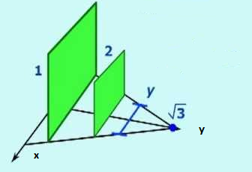The volume of a solid of known integrable cross section area A(x) from x = a to x = b is the integral of A from a to b

$$V=\int_{a}^{b}{A\left(x\right)dx}$$

The cross section can be any shape with know area's formula: square, rectangle, semi-circle, triangle,, ...

Find the volume of the solid whose base is the region bounded by $y=±\frac{x}{\sqrt{3}}∓1$

If cross sections taken perpendicular to the y‐axis are squares (picture)

What is the side length of the squares? What is the area of the squares?

The square-slice is from where to where?

The volume is

If cross sections taken perpendicular to the x‐axis are squares. Sketch

If cross sections taken perpendicular to the y‐axis are circle. Sketch

If cross sections taken perpendicular to the x‐axis are semicirle. Sketch

If cross sections taken perpendicular to the y‐axis are equilateral triangle. Sketch

If cross sections taken perpendicular to the y‐axis are right isosceles triangle . Sketch

Find the volume of the solid whose base is bounded by y = x + 1 and y = x2 -1, the cross sections perpendicular to the x-axis are rectangles of height 5. Sketch

The base is the region between the curves y = x2 and y = √x. The slices are squares which are perpendicular to the x-axis. Find the volume of the solid.

The solid is the region between y = x2 and y = −x2 from x = 0 to x = 2 whose cross sections, perpendicular to the x-axis, are circles. Find the volume. This volume can also be found by rotation the area under the curve y = x2 from x = 0 to x = 2 around the x-axis.

The base of the region is the area between y = √x, y = −x3 and x = 1, with isosceles right triangles perpendicular to the x-axis. Find the volume.

Sketch and find the volume of the solid whose base is bounded by the circle x2 + y2 = 4, the cross sections perpendicular to the x-axis are

1. Square b. Equilateral triangle c. Circle

Find the volume of a sphere whose radius is R

Find the volume of cylinder whose radius is R and length is h

Find the volume of square base pyramid whose height is h and base x2

I am thinking of a shape (hotdog bun? French bread?) form by the line

$y=\left\{\begin{matrix}.5\sqrt{5+x} ; -5<x<0 \\ .5\sqrt{5-x} ; 0≤x<5\end{matrix}\right.$ rotate around the axis. Sketch and find its volume

Find the volume of this shape <https://www.desmos.com/calculator/qpw2wh7wkg>

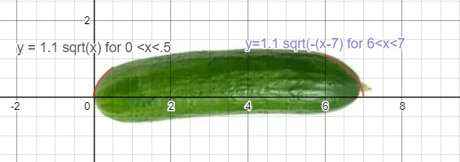

**Assessment**

Find the volume of a fruit you found on the nets. Send me a link

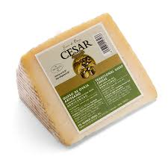

Find the volume of a cheese wedge.

Radius is _______ Angle is ______

